
CARBON REDUCTION PLAN GUIDANCE

Notes for Completion
Where an In-Scope Organisation has determined that the measure applies to the procurement, suppliers wishing to bid for that contract are required at the selection stage to submit a Carbon Reduction Plan which details their organisational carbon footprint and confirms their commitment to achieving Net Zero by 2050.
Carbon Reduction Plans are to be completed by the bidding supplier and must meet the reporting requirements set out in supporting guidance, and include the supplier’s current carbon footprint and its commitment to reducing emissions to achieve Net Zero emissions by 2050.
The CRP should be specific to the bidding entity, or, provided certain criteria are met, may cover the bidding entity and its parent organisation. In order to ensure the CRP remains relevant, a Carbon Reduction Plan covering the bidding entity and its parent organisation is only permissible where the detailed requirements of the CRP are met in full, as set out in the Technical Standard and Guidance, and all of the following criteria are met:
- The bidding entity is wholly owned by the parent;
- The commitment to achieving net zero by 2050 for UK operations is set out in the CRP for the parent and is supported and adopted by the bidding entity, demonstrated by the inclusion in the CRP of a statement that this will apply to the bidding entity;
- The environmental measures set out are stated to be able to be applied by the bidding entity when performing the relevant contract; and
- The CRP is published on the bidding entity’s website.

Bidding entities must take steps to ensure they have their own CRP as soon as reasonably practicable and should note that the ability to rely on a parent organisation’s Carbon Reduction Plan may only be a temporary measure under this selection criterion.
The Carbon Reduction Plan should be updated regularly (at least annually) and published and clearly signposted on the supplier’s UK website. It should be approved by a director (or equivalent senior leadership) within the supplier’s organisation to demonstrate a clear commitment to emissions reduction at the highest level. Suppliers may wish to adopt the key objectives of the Carbon Reduction Plan within their strategic plans.
A template for the Carbon Reduction Plan is set out below. Please complete and publish your Carbon Reduction Plan in accordance with the reporting standard published alongside this PPN.

Carbon Reduction Plan Template
Supplier name: Mcare24 LTD
Publication date: 15/12/2023

Commitment to achieving Net Zero
Mcare24 LTD is committed to achieving Net Zero emissions by 2030.

Baseline Emissions Footprint
Baseline emissions are a record of the greenhouse gases that have been produced in the past and were produced prior to the introduction of any strategies to reduce emissions. Baseline emissions are the reference point against which emissions reduction can be measured.

Baseline Year:2023
Additional Details relating to the Baseline Emissions calculations.
We are still analysing data to establish a baseline for evaluating figures. This is a draft based on identified areas.
Baseline year emissions:
EMISSIONS | TOTAL (tCO2e)
Scope 1 | Low Emissions Vehicles (LEVs)  Sum of emissions from fuel combustion, industrial processes, and fugitive emissions.  Total Scope 1 Emissions = 66.25 kg CO2 + 200 kg CO2 + 500,000 kg CO2e = 500,266.25 kg CO2 equivalent.
Scope 2 | Recycling program  50,000 kg CO2e (electricity) + 24,000 kg CO2e (steam) + 1,200 kg CO2e (heating) + 3,600 kg CO2e (cooling) = 78,800 kg CO2e.
Scope 3  (Included Sources) | Carbon reduction in electronic systems and reduction on paper.  100,000 tons (Purchased Goods and Services) + 25 tons (Business Travel) + 6 tons (Employee Commuting) + 20 tons (Upstream Transportation) = 100,051 tons of CO2e.
Total Emissions | 679117.25 kg CO2

Emissions reduction targets

In order to continue our progress to achieving Net Zero, we have adopted the following carbon reduction targets.

We project that carbon emissions will decrease over the next five years to 450 tCO2e by 2030. This is a reduction of 30 %

As a small company making our inaugural commitment to carbon reduction, our primary objective is to establish a baseline for our carbon footprint and initiate sustainable practices. While specific targets are currently under development, our overarching goal is to systematically reduce our emissions over time.

We are dedicated to implementing environmentally responsible measures and plan to set realistic, measurable targets aligned with our long-term commitment to mitigating climate impact.

As our carbon reduction initiatives progress, we will transparently communicate our targets and achievements, contributing to our journey toward a more sustainable future.

Progress against these targets can be seen in the graph below:

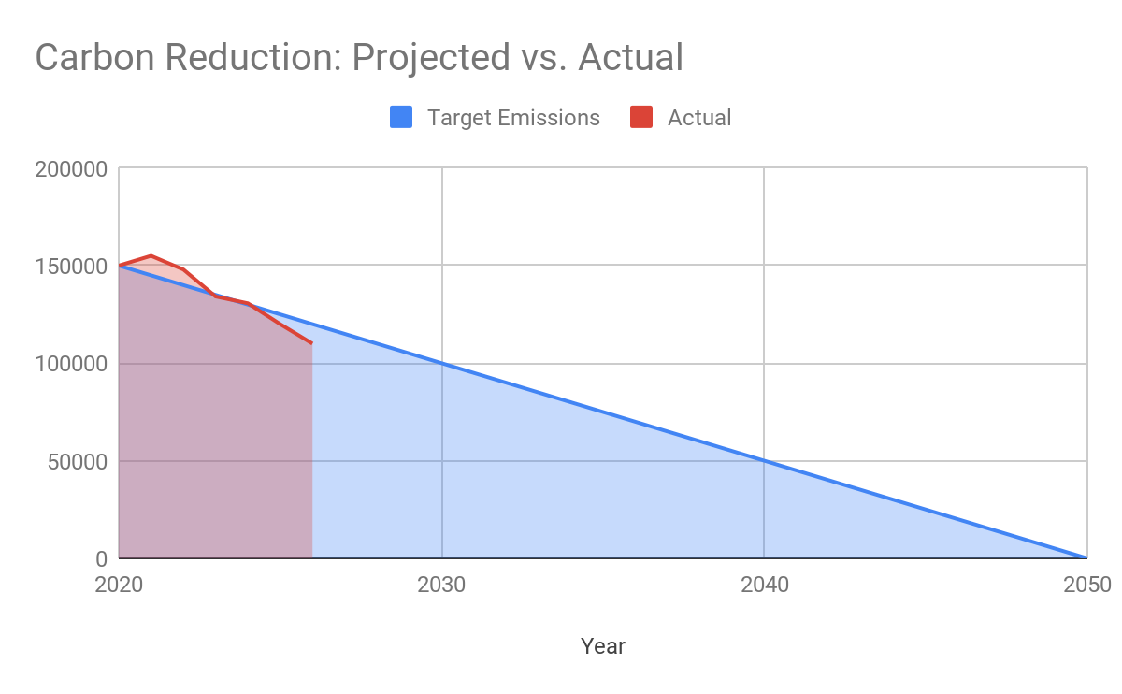

Carbon Reduction Projects

Completed Carbon Reduction Initiatives
The following environmental management measures and projects have been completed or implemented since the 2023 baseline.

Here are brief details on some carbon reduction projects:
- Implementation of the ISO 14001 environmental management system to enhance our environmental performance, ensure compliance with regulations, and systematically manage our environmental impact.
- Pursuing PAS 2060 certification to achieve carbon neutrality by quantifying, reducing, and offsetting our carbon emissions, thereby aligning with internationally recognized standards for carbon neutrality.
- Adoption of LED lighting with Passive Infrared (PIR) controls to optimize energy consumption, reduce electricity usage, and contribute to a more sustainable and efficient workplace.
- Implementation of revised travel policies to minimize company travel and flights, promoting virtual meetings and remote collaboration to reduce the organization's carbon footprint associated with business travel.
- Transitioning the company fleet to electric vehicles (EVs) to reduce reliance on fossil fuels, decrease emissions from transportation, and contribute to a cleaner and more sustainable mode of transportation.
- Conducting an energy audit to identify and implement energy-efficient technologies and practices.
- Upgrading lighting systems to LED or installing motion sensors to reduce unnecessary energy consumption.
- Implementing a comprehensive waste reduction and recycling program.
- Encouraging the use of recycled materials and sustainable packaging in product design.
- Offering incentives for employees to use public transportation, carpool, or bike to work.
- Assessing and selecting suppliers based on their commitment to sustainability.

In the future we hope to implement further measures such as:

- We aim to restore degraded or barren land by planting trees. They create forests on land that may have been unforested or regenerate forests that have been deforested either by human activities or natural disasters.
- Promoting the use of electric or hybrid vehicles within the company's fleet.
- Conducting awareness campaigns to educate employees about sustainable practices.
- Encouraging employees to contribute ideas for reducing the company's carbon footprint.
- Implementing smart building technologies to monitor and optimize energy usage.
- Installing solar panels or wind turbines to generate renewable energy on-site.
- Purchasing renewable energy credits or entering into power purchase agreements with renewable energy providers.

Declaration and Sign Off
This Carbon Reduction Plan has been completed in accordance with PPN 06/21 and associated guidance and reporting standard for Carbon Reduction Plans.
Emissions have been reported and recorded in accordance with the published reporting standard for Carbon Reduction Plans and the GHG Reporting Protocol corporate standard and uses the appropriate Government emission conversion factors for greenhouse gas company reporting.
Scope 1 and Scope 2 emissions have been reported in accordance with SECR requirements, and the required subset of Scope 3 emissions have been reported in accordance with the published reporting standard for Carbon Reduction Plans and the Corporate Value Chain (Scope 3) Standard.
This Carbon Reduction Plan has been reviewed and signed off by the board of directors (or equivalent management body).

Signed on behalf of the Supplier:
Petronila Ngeka
Registered Manager
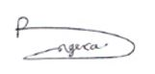
Date: 15/12/2023

Bidding supplier or ‘bidding entity’ means the organisation with whom the contracting authority will enter into a contract if it is successful.
Technical Standard can be found at: https://assets.publishing.service.gov.uk/government/uploads/system/uploads/attachment_data/file/991625/PPN_0621_Technical_standard_for_the_Completion_of_Carbon_Reduction_Plans__2_.pdf
Guidance can be found at: https://assets.publishing.service.gov.uk/government/uploads/system/uploads/attachment_data/file/991623/Guidance_on_adopting_and_applying_PPN_06_21___Selection_Criteria___3_.pdf
https://ghgprotocol.org/corporate-standard
https://www.gov.uk/government/collections/government-conversion-factors-for-company-reporting
https://ghgprotocol.org/standards/scope-3-standard

